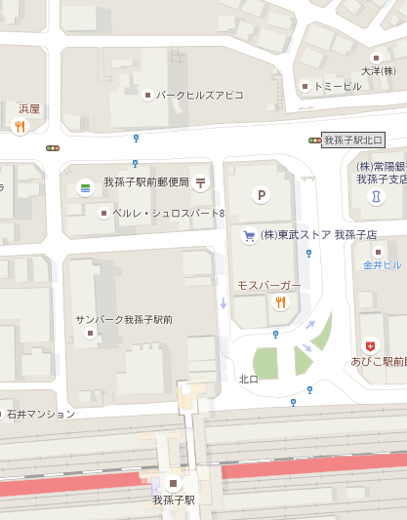

ｴｽﾊﾟ

新教室

ﾌｧﾐﾘｰﾏｰﾄ